Passport Summary

Current passport expires April 2017
Malpensia (Milan Italy) 07-29-07, 09-02-07, New York 09-02-07.

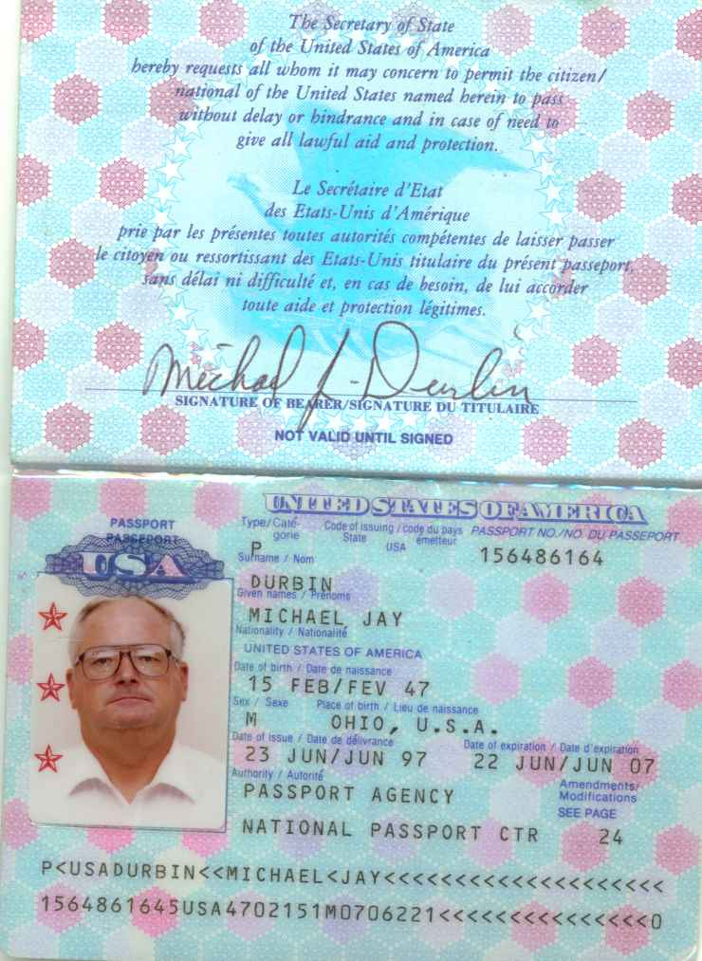 Passport as of 9/27/06
Gatwick 27 Jan. 1998, Gatwick 5 Feb. 1998, Malta 18 Aug. 2003, Malta 19, Aug., 2003,
Sinop Turkey 30 Aug. 2003, NY Kennedy Jun. 19, 2006, Ponta Delgada (Azores) 05 Aug. 2005,
Thira (Santorini) 30 May 2006, Athens 19 June 2006, Ykpaiha (Ukraine) 15, 16,23 & 25 May 2006,

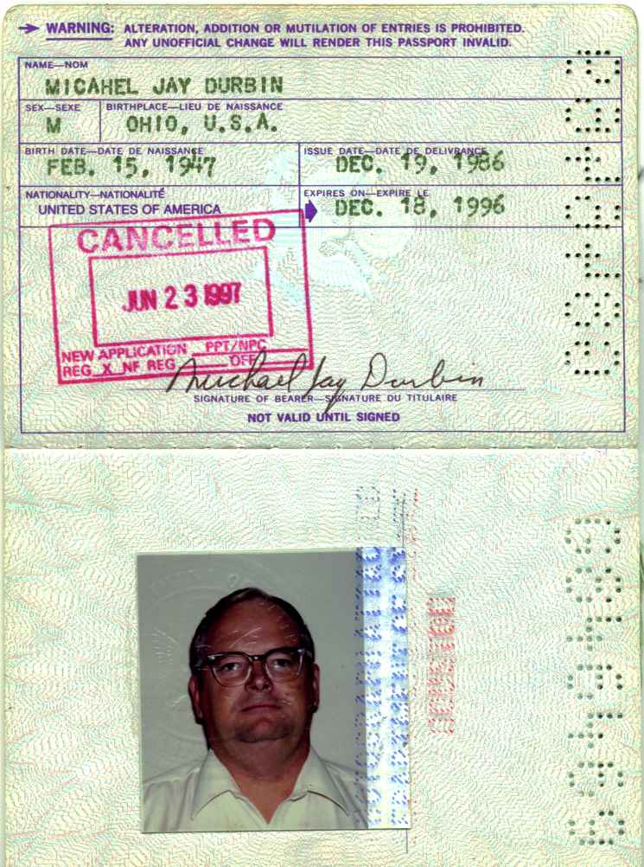 Expired Dec. 18, 1996
19 Aug. 1990 Quito (Ecuqdor), 29 Aug. 1990 Quayaquil (Galapagos),
14 April 1990 Pearson (Canada) Work Permit, 1 & 3 May 1992, 14 & 16 Nov. 1990 Salida (Venezuela)
25 Sept. 1989 & 11 April 1991 Rio and Brazilia (Brazil), 9 Nov. & 18 Dec 1991 Guayas (Galapagos),
28 Sept. 1992 Bermuda, 27 April 1992 Simon Bolivar (Venezuela), 3 & 30 Aug. 1993 Goldson (Belize),
Visa for India Dated June 12, 1991, 30 June & July 14 1994 Goldson (Belize),
14 & 21 May 1996 Soekarno-Hatia (India), 20 June 1990 Rodriquez Vargas (Mexico City)

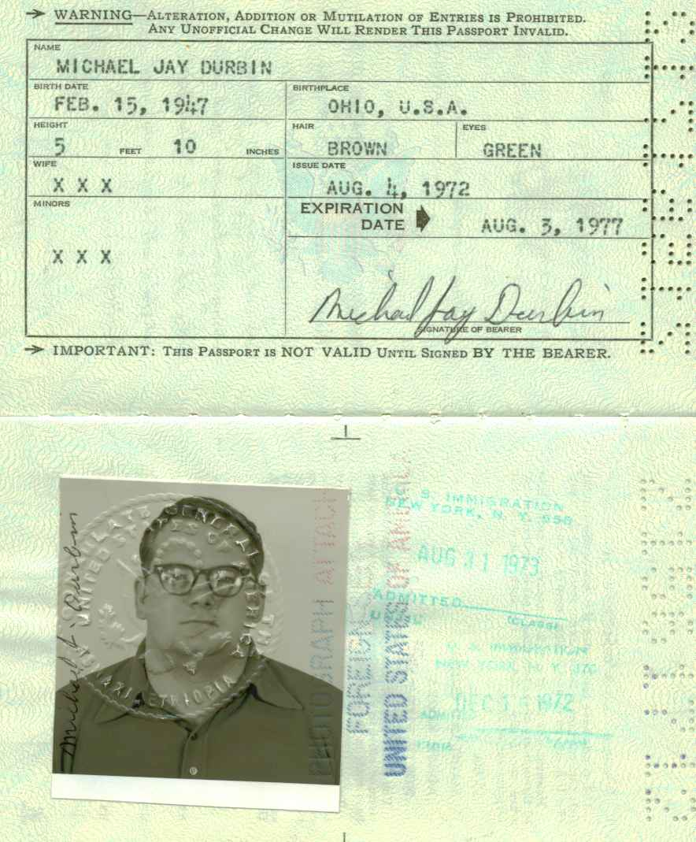 Expired Aug 3, 1977 Was issued at the US Consulate Asmara Ethiopia
15 Dec. 1972 Admitted NY Customs, 31 August 1973 Admitted NY Customs, 15 Dec 1972 Asmara (Ethiopia),
30 Aug. 1973 Asmara, 30 Aug. 1973 Athens (Greece)

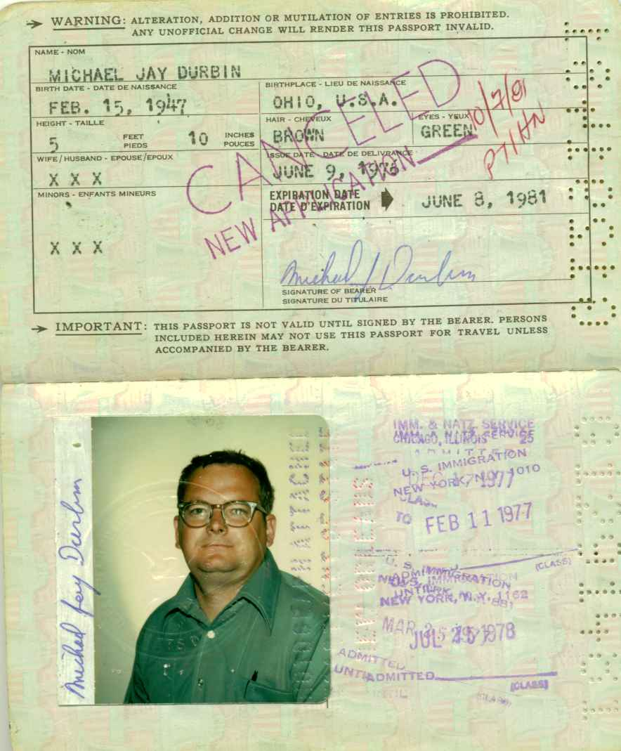 Expired June 8, 1981
Multiple USA Stamps, NY, Boston, Dallas, and Chicago, 5 Sept. 1979 Nedemland (Netherlands),
1 July 1977 Nedemland (Netherlands), 17 Oct. 1978 , 17 & 18 June 1977, 18 & 19 Apr 1978, Heathrow (England),
8 March 1980 Gatwick (England), 11&12 Feb. 1977 Paris (France), 14 & 18 July 1978 Cairo (Egypt),
SAUDI ARABIA as Follows: October 8 1976, Dec. 9, 1976, Feb. 23, 1977, April 4, 1977, May 20 1977, 8 Aug 1977, 18 July 1978, Nov 29 1977, June 20 1978, Oct 3 1978, Jan 8 1979, Feb 15, 1979, April 10 1979, May 16, 1979, July 2 1980, July 19 1979, Aug. 21 1979, Aug 22 1980, April 14, 1980, Jan 14 1980, March 4 1980.
30 Jan 1980 Cairo (Egypt), Sept. 17 1979 Argentina.
Yes that is a total of 21 trips to Saudi Arabia. Therefore there are that many in and outs of England, France, and Holland.

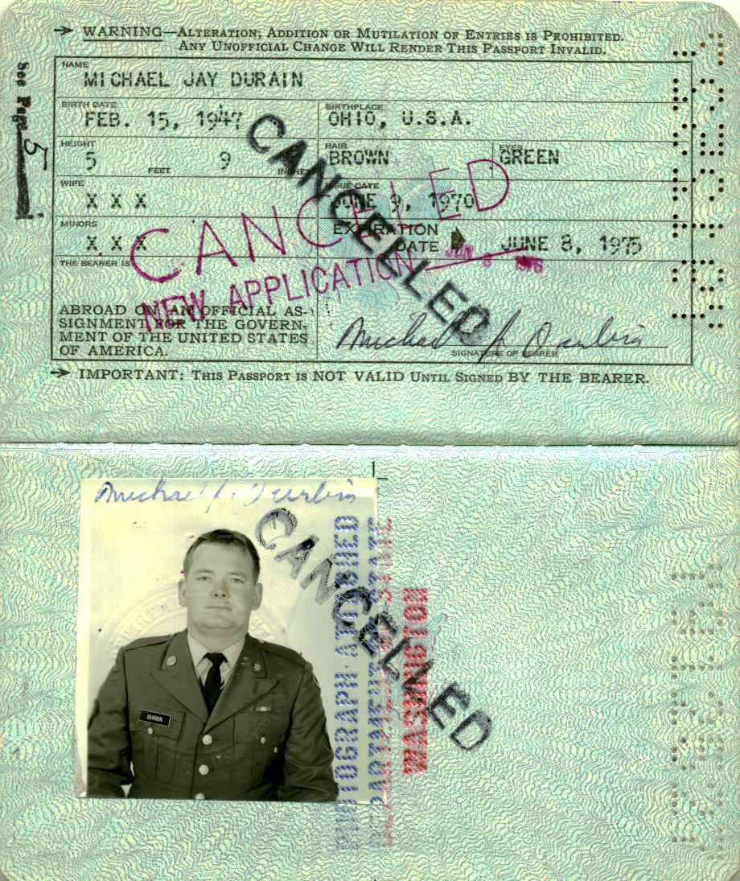 Expired June 8, 1975 (Note this was a RED Passport, indicating Military Intelligence)
22 July 1970 Asmara (Ethiopia), 12 Jan 1972 Asmara, 1 August 1972 Asmara, 29 October and 1 Sept. 1972 Athens (Greece), 21 & 22 August 1970 Athens,

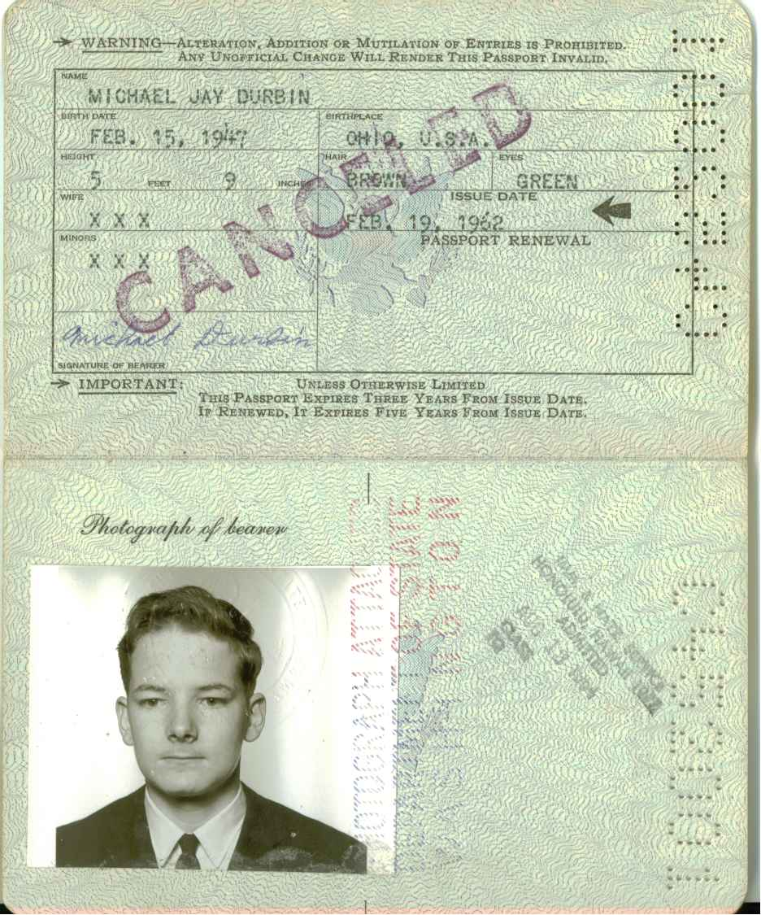 Expired Feb. 19, 1962 (Issued in San Jose California)
13 Aug. 1964 Hawaii, 27 Sept. 1962 Manila (Philippines), Sept. 12 1962 Visa to the Philippines, May 26 1964 Hong Kong

